New biocompatible cement synthesized using natural phosphate to medical use

Author ¹, Author ², Author ³.

Affiliation1
Affiliation2
Affiliation3

Abstract (250-word limit)
Hydroxyapatite (HA) and tricalcium phosphate are the most commonlyused ceramics in plastic surgery. HA is a naturally occurring mineral form of calcium apatite. ... Calcium phosphate cement is a synthetic HAcement that when mixed with ... of the PDMS chains.77 Medical grade silicone is biocompatible, Bone-grafting techniques either with autografts or allografts still represent a challenge for reconstructive surgery. Allografts and autografts are the current strategies for filling bone defects and subsequent repair but each have drawbacks. Synthetic bone-graft substitutes, developed in an effort to overcome the inherent limitations of autograft and allograft, represent an alternative strategy. Synthetic bone graft substitutes have the goal of mimicking the physical and mechanical nature of native tissue and to promote osteoconduction for bone regeneration. In addition these substitutes are capable to release drugs or growth factors in a temporally and spatially manner. Some biomaterials are employed to design biomimetic scaffold such as natural and synthetic polymers, ceramics, metallics and composites. The purpose of this paper is to provide an overview of the main biomaterials used for bone reconstruction.

Please insert Image/Figure
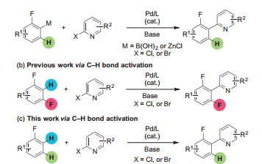
Recent Publications (maximum 5)
- Souza T. F., Magalhães M., Torres V. V., D’Elia E., Int. J. Electrochem Sci. 10 (2015) 22.
- Mohd H. H., Mohammed J. K., J Phy. Sci. 21 (2010) 1.
- ElHajjaji F., Greche H., Taleb M., ChetouaniA.,,Aouniti A., Hammouti B., J. Mater. Environ. Sci. 7 (2) (2016) 566-578.
- Bouknana D., Hammouti B., Messali M., Aouniti A., Sbaa M., Port. Electrochim. Acta, 32 (2014) 1-19.
- Ali A.I., Megahed H.E., El-Etre M.A., Ismail M.N., J. Mater. Environ. Sci. 5 (2014) 923-930

Biography (150-word limit)
 | Author has her expertise in evaluation and passion in improving the bone and cement used in dental medicine. Her focus is based on the use of natural phosphate to have application in health field. She was warded her PhD in 2013 from the University of …., Country. She published more than 20 papers. Her H-index is X on Scopus.  Email: drXXXXXXX@xxxmail.com

